**Exercise 4: Solution Reflection**

Last Updated 9.4.2018

Name: __ Olivia Doran_and Amanda Brandeen__________________________________

Date: ___November 27, 2018____________________________________________________

Course: ___Principles of Software Engineering_______________________________________

**In the box below, show your prototype, either with a photograph or a sketch. Then, include a full, written description of your prototype.**

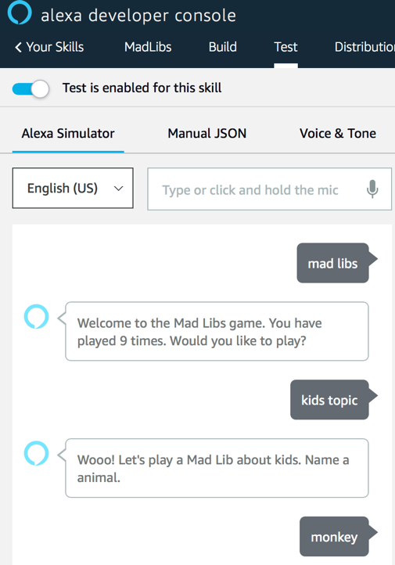

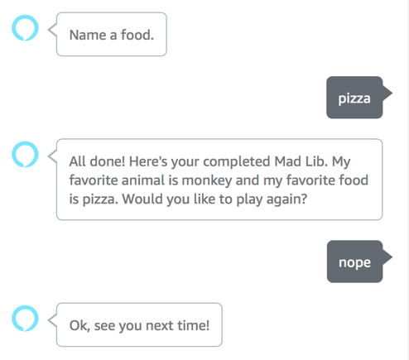

Our prototype is a Mad Libs Alexa skill that generates mad libs based off of different user responses. To start the skill, the user says, “mad libs”. To begin user interaction, Alexa welcomes the user to the skill and asks the user if he or she would like to play or not. If the user responds with an utterance that is recognized by our yes intent handler, then the game begins, or if the user responds with an utterance that is recognized by our no intent handler the game ends. In addition, instead of responding with an utterance indicating if you would like to play or not, you can specify which mad lib topic you want to play with. Currently we have the following topics: random, sports, Vanderbilt, nature, media, travel and kids. Once the game starts, Alexa asks the user to respond with a word that fits a specific category of one of our intents in order to fill the blanks in a mad lib. The intents we included are: actor, animal, city, color, food, movie, number, social media, sport, sports team, state, TV series, and weather. This wide range of intents allows the skill to generate creative and unique mad libs. In addition, we have written intent handlers that correspond to our intents, which tell our skill how to respond if the intent recognizes a user’s utterance or does not recognize a user’s utterance. Lastly, once all the blanks in the mad lib are filled with user inputs, a mad lib is generated and Alexa reads it to the user.

**In the box below, show your test of your prototype, either with photographs or sketches of your testing. Then, include a full, written description of your testing.**

Alexa developer console

Java Tests

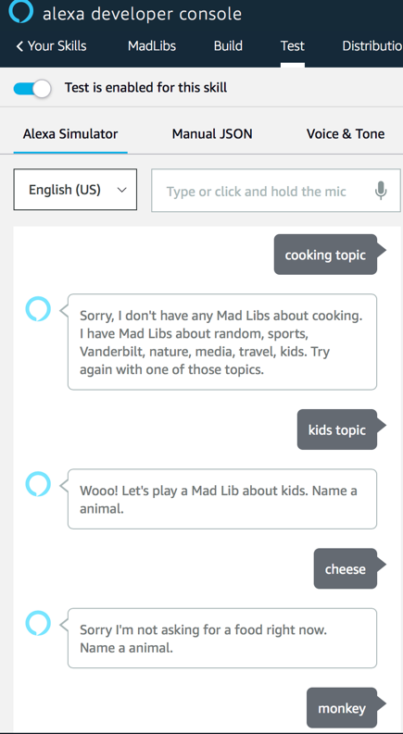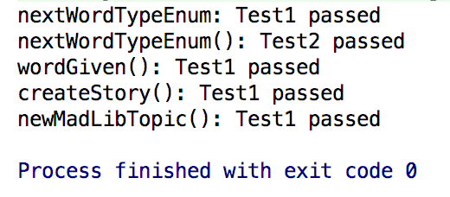

We have tested our code by using the Alexa developer console and by writing java tests that test our MadLibs class. First, we used the Alexa developer console to test because this console mimics how an Alexa device would respond if we deployed our code to one. Therefore, if you look at our Github account, you can see that we posted a “Developer Console Testing Script” which we used to test and can be used by others to test. In addition, Amazon has built-in tests in our intent handlers, such as checking if you really answered with a food if that is what the developer console is asking for. Second, we created java tests that test the functions written in our MadLibs class.

**In the box below, describe in words or pictures your final solution.**

For this assignment our prototype and our final solution are the same. However, if we had more time, we would deploy our code to an Alexa device and add more mad libs, intents and topics to increase the variety of the mad libs users can play with.

**Finally, tell us about at least one change you made to your prototype and why you made that change.**

We encountered a problem with storing our MadLib class in the session attributes. This variable was too large to be stored in this format. Therefore, we had to change our MadLib class to be a singleton. A singleton is a pattern that only allows a class to have one instantiated instance through the implementation of private constructors and a static member variable that is the one instance of that class (usually named instance). This pattern allows the current MadLib to be accessed from any of our intent handlers.